Day 59: Encoder and Decoder Using Verilog HDL

Encoder
Introduction: An encoder is a combinational logic circuit that converts an active input into a binary code.
Design: The encoder takes multiple input signals and generates a binary output corresponding to the active input.
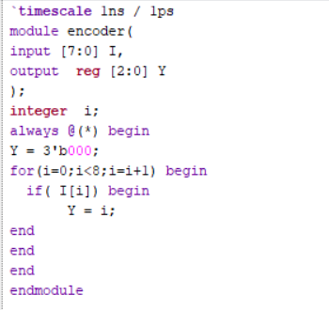
Testbench: Different input combinations are applied to the encoder using a testbench. The output binary code is observed and checked against the expected result.
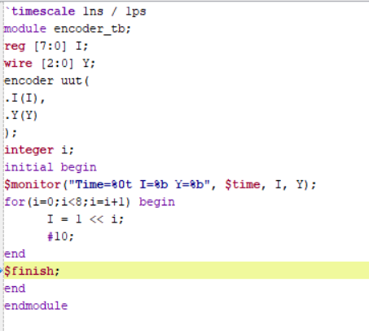
Assumption: Only one input is active at a time.
Waveform: The simulation waveform shows the input signals and their corresponding binary output codes. The output changes according to the active input.
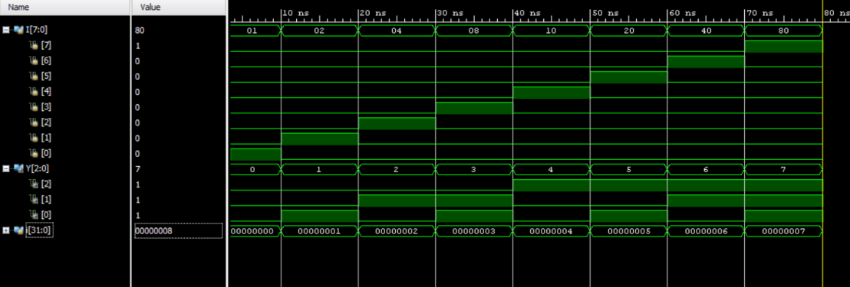
Schematic: The RTL schematic is generated in Xilinx Vivado to observe the internal logic structure and connections of the encoder.
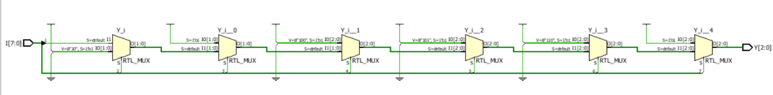

Decoder
Introduction: A decoder is a combinational logic circuit that converts a binary input code into a corresponding active output.
Design: The decoder takes a binary input and activates the corresponding output line according to the input value.
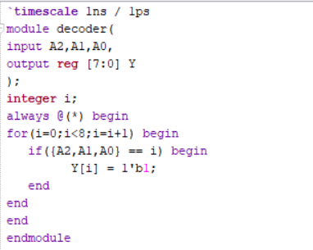
Testbench: Different binary input combinations are applied to the decoder using a testbench. The corresponding output is observed and verified.
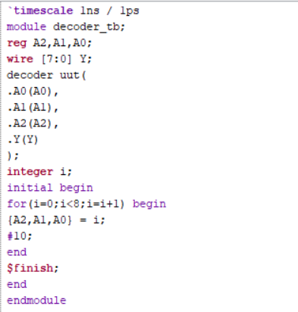
Waveform: The simulation waveform shows the binary input and the corresponding active output line. The expected output is checked for each input combination.
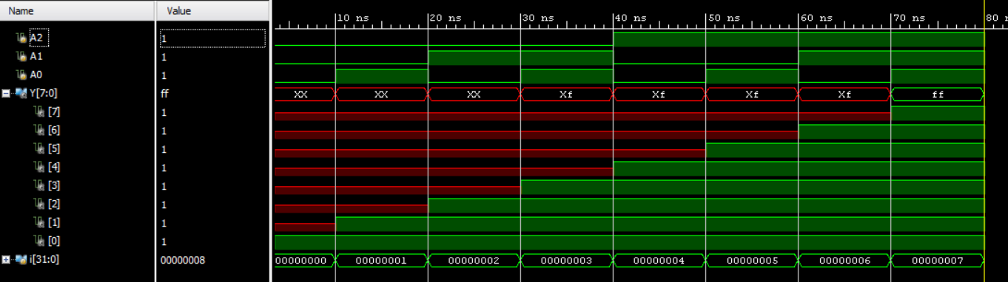
Schematic: The RTL schematic is generated in Xilinx Vivado to observe the internal logic structure and connections of the decoder.
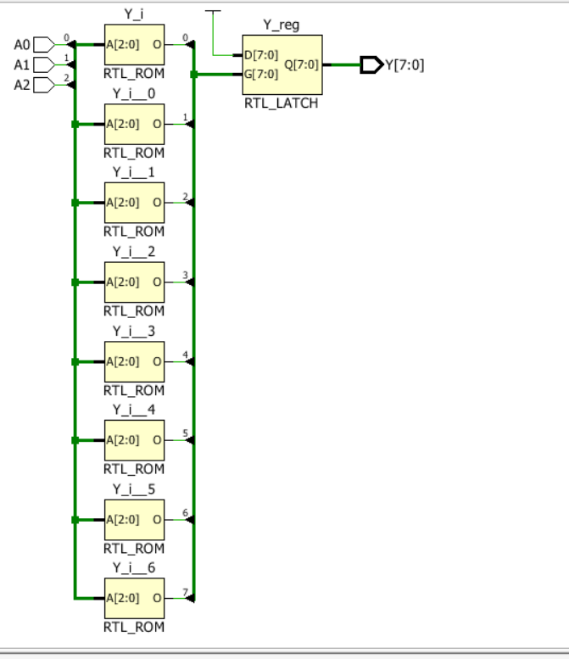
Observation
The encoder converts an active input into its corresponding binary code, while the decoder converts a binary input code into the corresponding active output. Both circuits are verified through simulation using Verilog HDL and Xilinx Vivado.
#PHNEENDRA.SINGUDASU

